Atascocita Presbyterian Church
(To Glorify God, Make Disciples, Meet Human Needs)
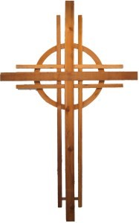

Cash Receipt
Date
Cash Total | $
Checks Total | $
Total Receipt | $

□ Funds Attached (or)
□ Other

Account Distribution and Description
Account | Amount | Description
 | $
 | $
 | $
 | $

Contact Treasurer Will Nees (wgnees@me.com) if you have any questions.

Please do not staple checks to the sheet. Paper clip or put into an envelope.

Received By ______________________________________

